**RESUME**

**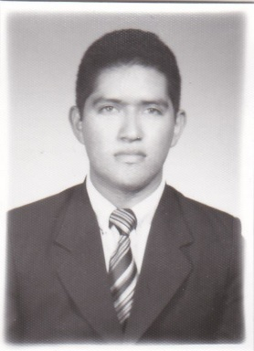César Eduardo Vásquez Tíu**

**Address:** 12 calle 13 – 84 zona 7 Castillo Lara

**Phone Number**: 42662121 - 24753916

**E-mail address**: [cesarvasz@gmail.com](mailto:cesarvasz@gmail.com)

**Id number**: 2126122980101

**Age**: 24

**Date of Birth**: February 29, 1992

|  |  |
| --- | --- |
| Objectives | |
| Do a good job with my experience I have and apply it in my laboral field. I also want to learn more to get more experience | |
| **LABORAL INFORMATION** | |
| Allied Global – Customer Service   * Claro Clients Support Service – February - October 2014 | |
|  |  |
| Education | |
| High School   * High School Diploma – Liceo Canadiense Centro Año 2013   Secudary School   * 7th to 9th – Colegio Mesoamericano – Years 2008 – 2010   Elementary School   * 1st to 6th – Escuela Oficial Mixta “25 de Septiembre” – Years 1998 - 2004   Technician Careers   * Repairs and Maintenance of Computers – Intecap Centro Tics – Year 2011 * Computers Operator – Intecap Centro Tics – Year 2012 * Web Design Junior – Intecap Centro Tics – Year 2013   Diplomas   * Administration of Windows and Linux Operating Sistems – Intecap Centro Tics – Year 2011 * Networking – Intecap Centro Tics – Year 2012 * Programming Concepts - Intecap Centro Tics – Year 2012 * IBA Scholarship (F.S. school) Programa Empleo Juvenil U.E. – Year 2016   LABORAL REFERENCES   * Allied Global Plaza Zona 4 Phone Number: 2419-9999   PERSONAL REFERENCES   * Ruben Martinez Phone Number: 4320-0186 * Gerardo Herrera Phone Number: 5511-4656 * Eduardo Andrino Phone Number: 5692-8221 | |
|  | |
|  | |

|  |
| --- |
|  |
| DPI  C:\Users\Eduardo\Documents\IMG_20131221_0001.jpg  C:\Users\Eduardo\Documents\IMG_20131221_0002.jpg |
|  |

**High School Diploma**